**Readme C2H2.txt**

I. OVERVIEW

A series of measurements were made on a variety of gaseous and liquid pool fires including the radiative heat flux emitted to the surroundings. This document briefly describes the acetylene results. Analogous results for pool fires burning other fuels are described elsewhere. The experiments are described in detail in Refs. [1-5].

Experiments were conducted varying the acetylene mass flux for fires burning in a quiescent environment in two circular burners (0.10 m and 0.38 m diameters) for idealized heat release rates varying from 1 kW to 50 kW. Measurements in the 16 associated files represent the time-averaged distributions of radiative heat flux emitted to the surroundings. The radiative flux results were used to determine the radiative fraction, a key global parameter characterizing the fraction of energy lost to the surroundings. A number of other measurements were made, including heat loss to the burner, sensible enthalpy fraction transported by the fire plume via convection, and the flame height (its minimum, maximum, and average values). It should be noted that Hostikka [6] used FDS to simulate the radiative flux distribution from methane fires.

II. EXPERIMENTAL DESCRIPTION

The experimental apparatus and procedure is reported in detail in [1, 3]. Steadily burning gaseous acetylene fires were established in a quiescent environment (after several minutes of burning). The rate of gaseous fuel delivery was controlled using calibrated flow meters (rotometers). The flow was determined using a dry test meter and stopwatch to measure the volume per unit time of fuel delivered to the burner. The dry test meter was fitted with a thermocouple and pressure gauge to correct, as needed, for variation in ambient conditions. The combined expanded measurement uncertainty for the burning rate was estimated as 4 % for the gaseous fuels. A warm-up period of 3 min to 10 min was required for the acetylene experiments to reach steady burning.

The first burner was circular with a 0.10 m inner diameter (and approximately a 0.0015 wall thickness) that was filled with a 0.03 m layer of sand below its rim; it had 3 mm (outer diameter) copper water-cooling lines embedded as a series of coils in the form of a loosely wound spiral located 1 cm below the surface of the sand and around the outside of the burner. Sand is a good insulator, so the surface temperature of the sand was at elevated temperatures as characterized by three thermocouples at the burner surface (r = 0, 2.5 cm, and 4.5 cm). The measured temperature varied radially across the surface with temperatures reaching steady values of a few hundred degrees after burner warm-up. An area-weighted average temperature is provided in Table 1. The actual radial temperature profile is listed in Table 2.

The second burner was made of porous sintered-bronze and was water cooled with a diameter of 0.38 m. The surface temperature of the burner can be estimated as approximately equal to the average temperature of the water in the burner, which can be determined from the measured burner inlet and outlet temperatures - with the average temperature of about 40 oC listed in Table 1. Table 3 lists the measured inlet and outlet temperature of the burner cooling water.

Calibrated water-cooled radiometers were used to measure the time-averaged radiative heat flux distribution along a cylindrical control surface surrounding the fire. The gauges had a time response of about 2 s. The view angle of the heat flux gauges was measured to be approximately 150 degrees, somewhat smaller than a full hemisphere. The gauges were calibrated using a secondary standard in a well-characterized radiometer facility [7].

About 10 water-cooled (1 in diameter) Medtherm 64 series[1]* Gardon total heat flux transducers were positioned along two perpendicular axes aligned with the pool fire burner. Figure 1 shows a schematic diagram of the experimental set-up. The first row of radiometers was positioned on a vertical axes located some distance away from the fire (Ro in Figure 1, where Ro is listed in Table 1 for each experiment). The radiometers were oriented horizontally on a radii directly facing the fire. The second row was oriented upwards positioned along the radius on the plane aligned with the burner surface. The radiative flux typically drops off very quickly in the radial direction, whereas in the vertical direction, the flux peaks at a vertical location equal to approximately 50% of the characteristic flame height and then drops to small values above the visible flame tip as illustrated in Figure 1 for a typical case. The measured signal was time-averaged for about one min. The uncertainty (with a coverage factor of two) in the radiative flux measurement was approximately equal to 10 % based on the repeatability of typical measurements. This is consistent with the results from an international round-robin study of Schmidt-Boelter gauges, which determined an uncertainty of 8 % to 14% among five labs [7]

.



Figure 1. A schematic diagram of the set-up used in the measurement of the radiative fraction

The energy per unit time emitted by the fire was determined by integrating the measured spatial distributions of radiant flux about a cylindrical surface surrounding the fire. The radiative heat loss fraction (χr) was is the ratio of the measured radiant power to the idealized fire heat release rate (the product of the measured mass burning rate and the heat of combustion of the fuel). The uncertainty in the value of χr (with a coverage factor of two) was estimated as about 9 %. A photo of acetylene burning in the 0.38 cm burner is shown in Figure 2. Also seen are the heat flux sensors.

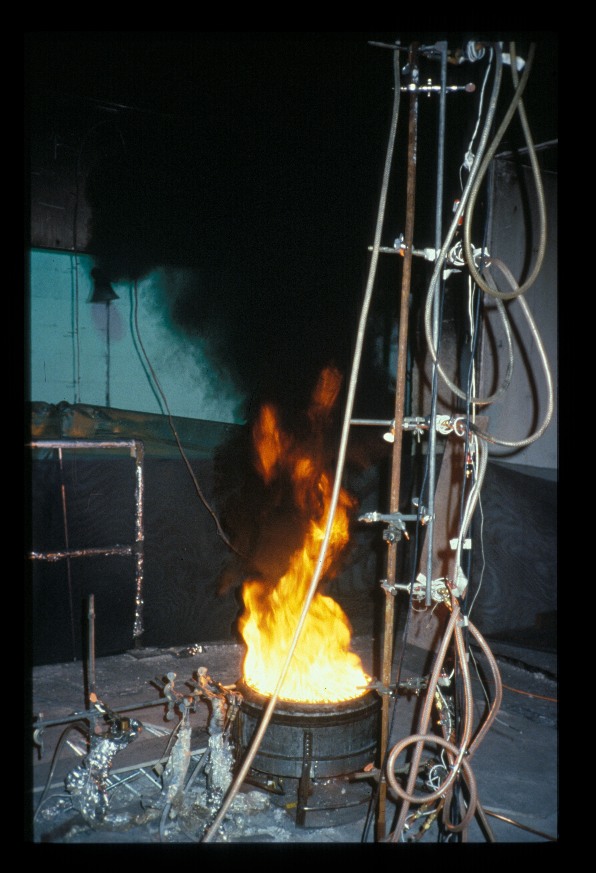

Figure 2 Photo of acetylene burning in the 0.38 cm burner. Acetylene produces copious amount of soot. Also seen are the heat flux sensors.

III. RESULTS

A summary of the results for the gaseous acetylene fire experiments is shown in Table 1, including the fire diameter (D), the mass flux (), the idealized heat release rate (Hc), the time-averaged radiative fraction (Xr), the convected enthalpy fraction (Xconv), the enthalpy fraction lost to the burner (Xb), the combustion efficiency (*X*a), and the average, maximum and minimum flame heights (Havg, Havg,, Havg, respectively). The actual heat release rate of the fire is equal to the product of the combustion efficiency and the idealized heat release rate (*X*a Hc). Ro in Table 1 describes the radial position of the vertical radiometer array shown in Figure 1. For each of the 16 fires listed in the table, a complementary file provides information on the measured radial and vertical heat fluxes. Figure 3 shows a screenshot of the file “Hamins_C2H2_38_cm_Test_5.csv“ as viewed in Wordpad. The file contains four columns of comma delimited data. The first and third columns are the r and z positions (see Figure 1) in meters. The second and fourth columns in the data files (see Figure 3) are the radial and vetical radiative heat fluxes in kW/m2.

The temperature of the burner surface was not uniform for the 0.10 m burner acetylene fires. The temperature distribution is seen in Table 2, which shows the measured surface temperature for the 0.10 m diameter (Tests A1-A5) as a function of r (see Figure 1), the radial distance from the burner center. The area weighted average temperature (*Tavg*) is listed in Table 2. Table 3 shows the measured cooling water temperature at the burner inlet and outlet for the 0.38 m diameter acetylene experiments (Tests B5-B15). For these cases, the average cooling water temperature (*Tavg*) listed in Table 3 provides an estimate of the burner surface temperature.

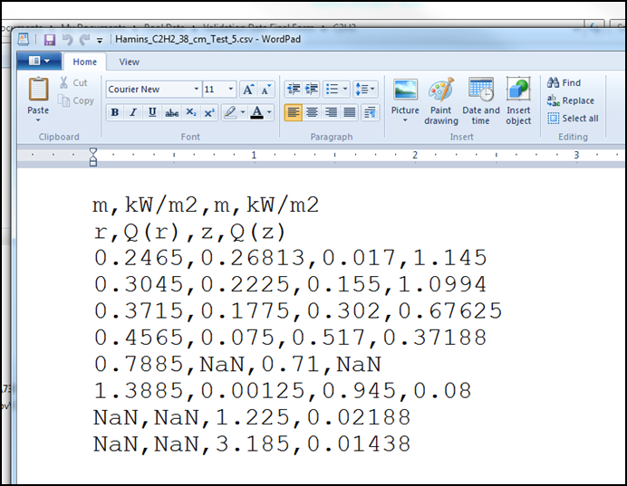

Figure 3. Screenshot from file “Hamins_C2H2_38_cm_Test_5.csv”, which provides 4 columns of comma delimited numbers that represent the locations (in the r and z locations seen in Figure 1) and associated measurements of the values of the radiative heat flux, Q(r), in the radial and vertical, Q(z), directions, respectively. The first two rows in the file provide the data units and the parameter name, respectively. The symbol “NaN” (not a number) implies that there is no data available for that particular entry.

IV. REFERENCES

1. Hamins et al., Pool Fire Measurements for Validation of Fire Models, NIST TN, in preparation, National Institute of Standards and Technology, Gaithersburg, MD, June 2016 (anticipated).
2. Hamins et al., Global Properties of Gaseous Pool Fires, Proceedings of the Twenty-Sixth Sym. on Combustion, 1429-1436, 1996.
3. Hamins et al., Estimate of Flame Radiance via a Single Location Measurement in Liquid Pool Fires, Combustion and Flame, 86:223-228, 1991.
4. Hamins et al., Characteristics of Pool Fire Burning, in Fire Resistance of Industrial Fluids, ASTM STP 1284 (Eds: G. Totten and J. Reichel), American Society for Testing and Materials (ASTM) Publication Number 04-012840-12, W. Conshocken, PA, pp. 15-41, 1995.
5. Klassen, M. and Gore, J.P., Structure and Radiation Properties of Pool Fires, Report NIST-GCR-94-651, National Institute of Standards and Technology, Gaithersburg, MD, 1994.
6. Hostikka et al.., Numerical Modeling of Small and Moderate-Scale Pool Flames using Large Eddy Simulation and Finite Volume Method for Radiation*,* *Proceedings* *Seventh Int. Sym. on Fire Safety Science*, 383-394 (2003).
7. Pitts et al., Report of Test FR 4014, “NIST/BFRL Calibration System for Heat-Flux Gages,” August 6, 2001.
8. Pitts et al., “Round Robin Study of Total Heat Flux Gauges,” NIST Special Publication 1031, October 2004.

Table 1. Summary of gaseous acetylene fire experiments including the fire diameter (*D*), the mass flux (), the idealized heat release rate (*Hc*), radiative fraction (*Xr*), convective fraction (*Xconv*), enthalpy fraction lost to the burner (*Xb*), the combustion efficiency (*X*a), actual heat release rate (*Xa* *Hc*), and the average, maximum and minimum flame heights (*Havg*, *Havg,, Havg,* respectively). *Ro* describes the radial position of the vertical radiometer array seen in Figure 1.

|  |  |  |  |  |  |  |  |  |  |  |  |  |  |  |  |  |  |  |  |  |  |  |
| --- | --- | --- | --- | --- | --- | --- | --- | --- | --- | --- | --- | --- | --- | --- | --- | --- | --- | --- | --- | --- | --- | --- |
| *Test* | *File*  *Name* | | | *D*  (m) | | (g/s) | | *R*0 (m) | *Hc* (kW) | | *Xr*  *( - )* | | *Xconv*  *( - )* | *Xb*  *( - )* | | *Xa*  *( - )* | *Xa* *Hc* (kW) | *Havg*  (m) | *Hmax*  (m) | | *Hmin*  (m) | |
| A1 | Hamins_C2H2_10_cm_Test_1 | | | 0.10 | | 0.00943 | | 0.132 | 0.45 | | 0.09 | | 0.54 | 0.37 | | 1* | 0.45 | - | - | | - | |
| A2 | Hamins_C2H2_10_cm_Test_2 | | | 0.10 | | 0.0116 | | 0.132 | 0.56 | | 0.12 | | 0.57 | 0.31 | | 1* | 0.56 | 0.031 | 0.047 | | 0.021 | |
| A3 | Hamins_C2H2_10_cm_Test_3 | | | 0.10 | | 0.0188 | | 0.132 | 0.90 | | 0.16 | | 0.64 | 0.20 | | 1* | 0.90 | 0.086 | 0.135 | | 0.051 | |
| A4 | Hamins_C2H2_10_cm_Test_4 | | | 0.10 | | 0.0267 | | 0.132 | 1.29 | | 0.24 | | 0.62 | 0.14 | | 1* | 1.29 | 0.155 | 0.272 | | 0.097 | |
| A5 | Hamins_C2H2_10_cm_Test_5 | | | 0.10 | | 0.0320 | | 0.132 | 1.54 | | 0.27 | | 0.61 | 0.12 | | 1* | 1.54 | 0.158 | 0.279 | | 0.106 | |
| A6 | Hamins_C2H2_38_cm_Test_5 | | | 0.38 | | 0.259 | | 0.387 | 12.5 | | 0.12 | | 0.58 | 0.30 | | 0.99 | 12.4 | 0.175 | 0.359 | | 0.101 | |
| A7 | Hamins_C2H2_38_cm_Test_6 | | | 0.38 | | 0.229 | | 0.505 | 11.0 | | 0.07 | | 0.59 | 0.34 | | 1.00 | 11.0 | 0.141 | 0.264 | | 0.082 | |
| A8 | Hamins_C2H2_38_cm_Test_7 | | | 0.38 | | 0.424 | | 0.505 | 20.4 | | 0.18 | | 0.54 | 0.23 | | 0.97 | 19.8 | 0.253 | 0.521 | | 0.160 | |
| A9 | Hamins_C2H2_38_cm_Test_8 | | | 0.38 | | 0.648 | | 0.505 | 31.3 | | 0.27 | | 0.50 | 0.18 | | 0.94 | 29.4 | 0.388 | 0.633 | | 0.178 | |
| A10 | Hamins_C2H2_38_cm_Test_9 | | | 0.38 | | 0.793 | | 0.687 | 38.2 | | 0.32 | | 0.48 | 0.15 | | 0.92 | 35.1 | 0.512 | 0.939 | | 0.224 | |
| A11 | Hamins_C2H2_38_cm_Test_10 | | | 0.38 | | 0.996 | | 0.687 | 48.0 | | 0.34 | | 0.45 | 0.14 | | 0.90 | 43.2 | 0.562 | 0.894 | | 0.305 | |
| A12 | Hamins_C2H2_38_cm_Test_11 | | | 0.38 | | 1.294 | | 0.687 | 62.4 | | 0.31 | | 0.41 | 0.12 | | 0.86 | 53.7 | 0.592 | 1.004 | | 0.343 | |
| A13 | Hamins_C2H2_38_cm_Test_12 | | | 0.38 | | 1.582 | | 0.687 | 76.3 | | 0.31 | | 0.39 | 0.10 | | 0.82 | 62.6 | 0.526 | 1.035 | | 0.310 | |
| A14 | Hamins_C2H2_38_cm_Test_13 | | | 0.38 | | 2.265 | | 0.687 | 109.2 | | 0.29 | | 0.34 | 0.08 | | 0.73 | 79.7 | 0.493 | 0.903 | | 0.290 | |
| A15 | Hamins_C2H2_38_cm_Test_14 | | | 0.38 | | 2.431 | | 0.687 | 117.2 | | 0.28 | | 0.33 | 0.09 | | 0.71 | 83.2 | 0.533 | 0.817 | | 0.336 | |
| A16 | Hamins_C2H2_38_cm_Test_15 | | | 0.38 | | 2.794 | | 0.687 | 134.7 | | 0.28 | | 0.31 | 0.06 | | 0.66 | 88.9 | 0.577 | 0.794 | | 0.303 | |
|  | |  |  | |  | |  |  |  |  | |  | | |  | |  | | |  | |  | |  |  |

Table 2. Measured surface temperature for the 0.10 m diameter acetylene fire experiments as a function of r (see Figure 1), the radial distance from the burner center. *Tavg* is the area weighted average temperature.

|  |  |  |  |  |
| --- | --- | --- | --- | --- |
| *Test* | *T(r=0)*  (oC) | *T(r=0.025 m)*  (oC) | *T(r=0.045 m)*  (oC) | *Tavg*  (oC) |
| A1 | 375 | 483 | 360 | 422 |
| A2 | 386 | 437 | 414 | 424 |
| A3 | 360 | 466 | 457 | 448 |
| A4 | 395 | 459 | 463 | 458 |
| A5 | 407 | 469 | 450 | 458 |

Table 3. The measured temperature of the cooling water at the burner inlet and outlet for the 0.38 m diameter acetylene fire experiments. *Tavg* is the average temperature water temperature.

|  |  |  |  |
| --- | --- | --- | --- |
| *Test* | *Tinlet*  (oC) | *Toutlet* (oC) | *Tavg*  (oC) |
| B5 | 19 | 74 | 47 |
| B6 | 19 | 63 | 41 |
| B7 | 19 | 62 | 41 |
| B8 | 18 | 60 | 39 |
| B9 | 16 | 59 | 38 |
| B10 | 15 | 63 | 39 |
| B11 | 13 | 61 | 37 |
| B12 | 13 | 66 | 40 |
| B13 | 13 | 68 | 41 |
| B14 | 13 | 73 | 43 |
| B15 | 13 | 68 | 41 |

1. * Certain commercial entities, equipment, or materials may be identified in this document in order to describe an experimental procedure or concept adequately. Such identification is not intended to imply recommendation or endorsement by the National Institute of Standards and Technology, nor is it intended to imply that the entities, materials, or equipment are necessarily the best available for the purpose.